Heating Box Guide – Beta

Marcus Thelin Schmidt

Marcus.thelin.schmidt@gmail.com

0735951004

Table of Contents

Parts 3

Assembly 5

Box 5

Electronics 10

Software 15

How to Use 16

Step 1 - Assembly 16

Step 2 – Download Programs 17

Step 3 – Install scripts from GitHub 17

Arduino 17

Python/PyCharm 18

MATLAB 25

Step 4 – Operate 26

USB port 26

Configure and Upload Arduino Code 29

Run Python script 29

# Parts

[Arduino Uno](https://www.digikey.se/sv/products/detail/arduino/A000066/2784006)

[USB-A to USB-B (Arduino to Computer)](https://se.rs-online.com/web/p/usb-cables/1862787?searchId=2841ce73-240f-48a9-99e1-e1d2efeebf47&gb=)

[Arduino Housing (3D-printed) (only used the base)](https://www.thingiverse.com/thing:713091)

[ESP32](https://se.rs-online.com/web/p/microcontroller-development-tools/2863990?searchId=185077ee-ef9c-45eb-9a70-0a54b6ee1d07&gb=s)  
  
[Logic Shifter](https://se.rs-online.com/web/p/development-tool-accessories/2881928?gb=a)  
  
[USB-C to USB-B (ESP32 to Computer)](https://se.rs-online.com/web/p/usb-cables/2513300?gb=s)

[Light Dimming Module (RobotDyn 230V AC)](https://www.amazon.com/Genuine-Programmable-Light-Dimmer-110V/dp/B0893K6ZPK/ref=pd_rhf_se_s_pd_sbs_rvi_d_sccl_2_2/142-3971428-9762515?pd_rd_w=EzLsG&content-id=amzn1.sym.9c71db11-3b2f-49a1-9fef-afd524b20130&pf_rd_p=9c71db11-3b2f-49a1-9fef-afd524b20130&pf_rd_r=PSHDPSAAJWPTSBTCJG2D&pd_rd_wg=47jUT&pd_rd_r=21dd7f5c-6bcb-4f2b-b256-ce4b8200f937&pd_rd_i=B0893K6ZPK&psc=1)

[3-way Extension Cord](https://www.clasohlson.com/se/Grenuttag-3-vags-3-m-kabel/p/36-8901)

[Breadboard](https://se.rs-online.com/web/p/breadboards/1892277?searchId=d875f1f3-4e14-474f-bbc1-ec9745237753&gb=s)

[Temperature Sensor (DHT22)](https://www.digikey.se/sv/products/detail/dfrobot/SEN0137/6588461)

[Shrink Tube](https://se.rs-online.com/web/p/heat-shrink-tubing/3948315?searchId=e43b91ff-40f6-46fe-a619-6fa9b1380bd3&gb=s)

[Colored Thin Wires (22 AVG)](https://www.digikey.se/sv/products/detail/sparkfun-electronics/PRT-11367/5956251?s=N4IgTCBcDaIAoCUAqBaAjGgzANgOwgF0BfIA)

[230V Plugs (EU)](https://se.rs-online.com/web/p/mains-plugs/7050822?searchId=555f2de7-51ca-4640-96db-96d3bd88b19d&gb=s)

[Infrared Heat Lamp](https://se.rs-online.com/web/p/heat-lamps/7960117?searchId=5944971f-c24b-447d-a794-ff9aa9c37aab&gb=s)

[Lamp Holder](https://se.rs-online.com/web/p/lamp-holders/2678108?searchId=c9a46c65-eb9f-4a00-8b60-3107da5b84d8&gb=s)

[40mm Fans:](https://www.digikey.se/sv/products/detail/nidec-components-corporation/F410T-05LC/1165524)

[Fan Mounting (3D-printed)](https://www.printables.com/model/40322-simple-2020-40mm-fan-mount)

[Fine Insect Metal Mesh](https://www.vidaxl.se/e/vidaxl-insektsnat-aluminium-100x1000-cm-silver/8718475880639.html)

[Sturdy Metal Mesh (as support for the Insect Mesh)](https://www.clasohlson.com/se/Anslagstavla-metallnat-50-x-70-cm/p/44-5000)

[Plywood](https://www.byggmax.se/konstruktionsplywood-15-mm)

[Square Wood Column](https://www.byggmax.se/regel-45x45-p08145045)

[Acrylic Plate](https://www.byggmax.se/akrylskiva-3mm-p21190#1225=88061)

230V-approved wires: Salvaged from old extension cords and similar

[Arduino Crimps (Male)](https://se.rs-online.com/web/p/crimp-contacts/6881442?searchId=b2bf5832-e911-41f9-a393-e8617a3e6456&gb=s)

[Arduino Crimps (Female)](https://se.rs-online.com/web/p/crimp-contacts/8201529?gb=s)

[Arduino Crimp Holders (4-way)](https://se.rs-online.com/web/p/wire-housings-plugs/6812824P?gb=s)

[Fuse (2.5A)](https://www.digikey.se/sv/products/detail/littelfuse-inc/031202-5HXP/777236)

[Fuse Holder](https://www.digikey.se/sv/products/detail/littelfuse-inc/01500332H/3425489?s=N4IgTCBcDaIGYDYDsSCsBaAdgExAXQF8g)

[M4 inserts](https://se.rs-online.com/web/p/threaded-inserts/4257531?searchId=739c7d54-33a0-4a4e-9d50-15a13f68af5f&gb=s)

[M4 Bolts (recommend getting slightly longer ones)](https://www.ahlsell.se/products/infastning/maskingangad-skruv/maskinskruv/100676)

[M3 Bolts](https://www.byggmax.se/skruv-mrx-fzb-3x30mm-p2420628)

Miscellaneous:

* Screws (fastening Lamp Holders and Fans onto the floor)
* Bolts (M3 for fans, M4 for rest)
* Nuts (M3 for fans)
* Tape
* Sandpaper
* Epoxy
* Aluminum Foil

Tools:

* Wire stripper
* Soldering station (+tin & flux)
* Heat gun/lighter for shrinking tube
* Screwdriver
* Electric Saw (for wood and plastic)
* Manual Saw (for smaller wood parts)
* Bench Pillar Drill or Drill Stand (to get straight perpendicular holes)
* Crimping Tool (for Arduino Crimps)
* Multimeter

# Assembly

The box is separated into several larger parts as well as all the electronics. This part of the guide will show how to first assemble the larger parts “Box” and then how to connect all the “Electronics”.

## Box

First step is to identify the bottom plate and the right plate of the box. The bottom plate is easy to see as it has gotten the lamp holders, fans and some cables attached to it. The right plate has a large “R” written on its’ sides, along with the text “Inner” on one side and “Outer” on the other. Screw on the Right plate onto the right side of the bottom plate (shown by the letter “R”).

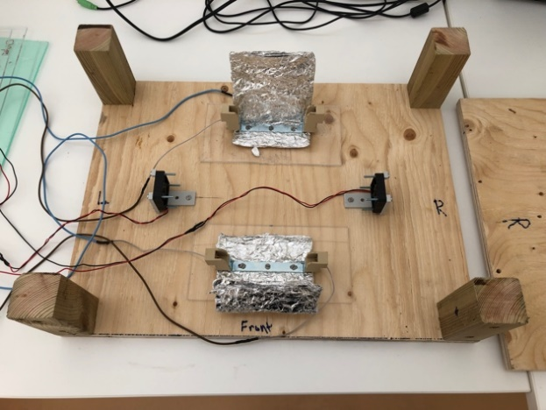

Figure 1

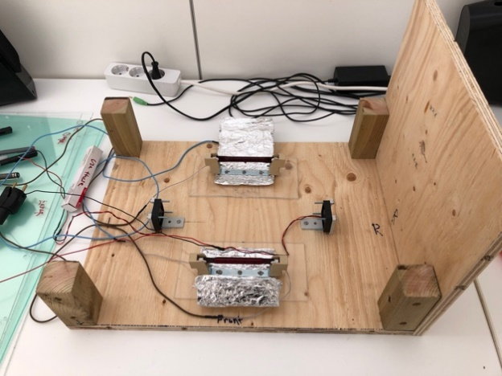

Figure 2

Make sure the side plate is firmly attached with all screws, but do not screw too hard as there is a risk of the screws just piercing through the wooden material of the side plate (figure 2).

At this step you can also connect the heating lamps into the lamp holders (figure 3).

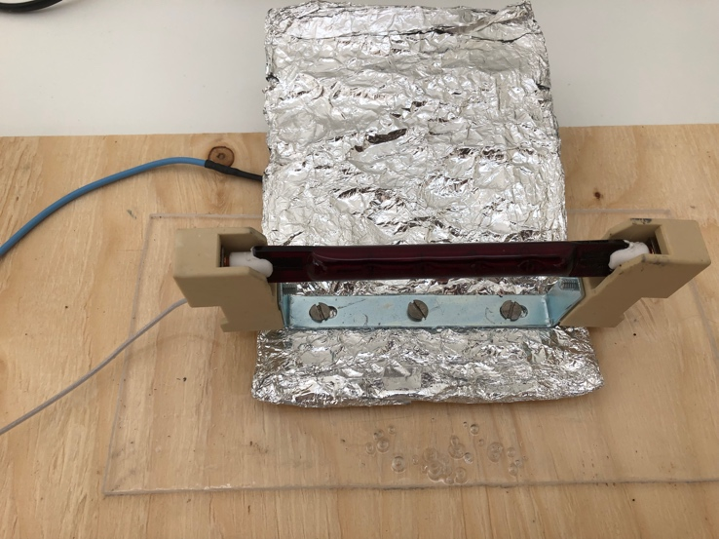

Figure 3

Fold the aluminum cover over the lamp to protect the bright light to get straight into the users’ eyes. Also, slightly fold the bottom part of the aluminum cover upwards to protect the plastic bottom under the lamp holder from overheating and melting by direct heat from the lamp.

Next step is the most crucial as far as time spent assembling is concerned. If this part is done incorrectly, it will take a lot of time to go back and fix it later. You want to have all the cables going in/out of the box to fit in the opening at the bottom of the left side plate (figure 5 and figure 6).

As figure 4 displays, organize all the cables towards the left. It is two set of cables from the lamp holders, two set of cables from the fans and twisted set of cables from the sensors (you can use up to four sensors at the same time).

Figure 4

When all cables have been found and organized you want to attach the left side plate marked with an “L” as well as “Outer” and “Inner” on respective sides (figure 5).

Figure 5

Figure 6

After this, you want to find the transparent plastic plate for the back of the box (figure 7). It has “Back”, “Inner” and “Outer” written on it. It is important it is the correct plate for each side even here as the screw holes are a tight fit customized for each side.

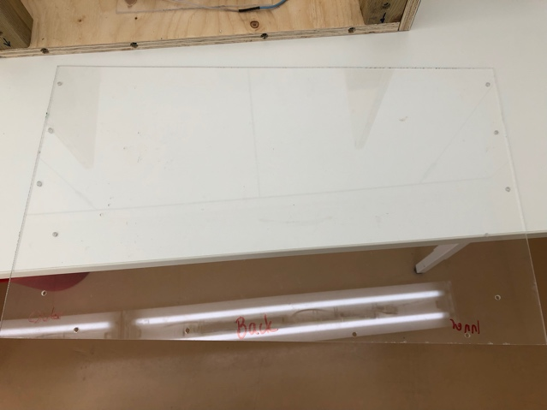

Figure 7

Figure 8

Now do the same for the front (figure 9 and 10).

Figure 9

Figure 10

Only remaining part of the box is the top plate. This part does not attach with screws or anything similar. This is intentionally done to have it easily removable as the user most likely want to get access into the box on a regular basis during experiments. If a tighter fit is sought after, the user can use silver tape to secure the top plate. The top plate is marked with “Top” (figure 11 and figure 12).

Figure 11

Figure 12

How to attach the sensors inside the box will be shown in the next chapter “Electronics”.

## Electronics

The electronics setup consists of:

* Arduino
* ESP32
* Logic Shifter
* Dimming Module
* 3-way extension cord
* Breadboard
* 1-4 sensors
* 2 lamp holders
* 2 fans
* USB connector(s)

As shown during the box assembly the two fans, lamps holders and sensors are within the box with their cables going out (figure 5). The other parts are packed together in a small electronics box outside (figure 13).

Figure 13 (old photo from Alpha version without Logic shifter and ESP32, but not important for this part)

First step is to pull the cables from the lamp holders, fans and sensors through the opening of the small electronics box if they are not already there (figure 14).

Figure 14

Then connect the two lamp holder plugs into the extension cord (figure 15).

Figure 15

Next step can be a bit tricky as it requires the user to accurately put all the small cables into the correct slots on the Arduino, ESP32, Logic shifter, breadboard and dimming module. If something is not working correctly with the box when trying to run it later on, this is a part of the guide to go back to and reassure everything is connected the way it should.

Arduino to Breadboard connections

The red wire goes from 5V slot on the Arduino to the left column on the breadboard and the black wire from “GND” on the Arduino to the right column on the breadboard, see figure 16. The breadboard in figure 16 is rotated 90 degrees and missing the ESP32 and Logic shifter compared to the board in the electronics box, but the wiring is still the same.

Figure 16

This connection allows 5V to be accessed from the entire vertical row up from the red wire on the breadboard. Likewise, ground (GND) can be accessed from the entire vertical row up from the black wire on the breadboard. When these are labelled on connections below you can connect it to any of the slots on the respective rows.

Fan connections

*Fan 1:*

Red 🡪 4 (Arduino)

Black 🡪 GND (breadboard)

*Fan 2:*

Red 🡪 7 (Arduino)

Black 🡪 GND (breadboard)

Sensor connections

Up to 4 different sensors can be used at the same time. In the pictures presented in this guide, only two have been in use as it was needed for the latest experiment. It’s important to keep in mind which sensor is connected into which slot on the Arduino as this will determine which sensor is represented as 1,2,3 or 4 in the code. It is labelled as below:

*Sensor 1:*

Red 🡪 5V (breadboard)

Black 🡪 GND (breadboard)

Green (signal) 🡪 11 (Arduino)

*Sensor 2:*

Red 🡪 5V (breadboard)

Black 🡪 GND (breadboard)

Green (signal) 🡪 10 (Arduino)

*Sensor 3:*

Red 🡪 5V (breadboard)

Black 🡪 GND (breadboard)

Green (signal) 🡪 9 (Arduino)

*Sensor 4:*

Red 🡪 5V (breadboard)

Black 🡪 GND (breadboard)

Green (signal) 🡪 8 (Arduino)

Logic Shifter connections

A logic shifter is employed to allow for communication between the Arduino and ESP32 using different voltage levels.

*Arduino to Logic Shifter:*

5V (Breadboard) 🡪 HV (Logic Shifter)

GND (Breadboard) 🡪 GND (HV side Logic Shifter)

13 (Arduino) 🡪 B2 (Logic Shifter)

12 (Arduino) 🡪 B1 (Logic Shifter)

*Logic Shifter to ESP32:*

LV (Logic Shifter) 🡪 3.3V (ESP32)

GND (LV side Logic Shifter) 🡪 GND (ESP32)

A2 (Logic Shifter) 🡪 RX2 (ESP32)

A1 (Logic Shifter) 🡪 TX2 (ESP32)

Extension cord to Dimming module connections

Brown 🡪 “IN”

Blue 🡪 “N”

Black 🡪 “Out”

See figure 17.

Figure 17

Dimming module to Arduino connections

White (PSM) 🡪 3 (Arduino)

Green (Z-C) 🡪 2 (Arduino)

Blue 🡪 GND (breadboard)

Red 🡪 5V (breadboard)

Arduino to Laptop connection

Connect the large black USB-A to USB-B cable from the Arduino to the laptop that will be used during experiments.

ESP32 to Laptop connection

Connect the large black USB-C to USB-B cable from the ESP32 to the laptop that will be used during experiments.

Figure 18, all components connected including ESP32 and Logic Shifter

To attach the sensors in the desired location within the box, it has previously been used double-sided silver tape on the back of the sensor and then put on the inside box’s side plates. This way it’s easily removable and adjustable (figure 19).

Figure 19

Everything is now assembled in preparation for operation. Go to chapter “How to Use” to follow the subsequent steps to get it up and running.

# How to Use

## Step 1 - Assembly

Follow the steps shown in the chapter “Assembly”.

## Step 2 – Download Programs (SKIP THIS STEP IF REGULAR USER)

The following programs were used to develop the software for the heating box:

* Arduino IDE (<https://www.arduino.cc/en/software>)
* PyCharm, Community Edition (<https://www.jetbrains.com/pycharm/download>, Scroll down for Community Edition)
* Python

## Step 3 – Install software from GitHub

Go to <https://github.com/MarcusTSgithub/HeatBox_Beta>

Locate the “Releases” tab on the right hand side and click it (figure 20)

Figure 20

Now download either the latest Windows or MacOS version by clicking the “.zip”-file (figure 21)

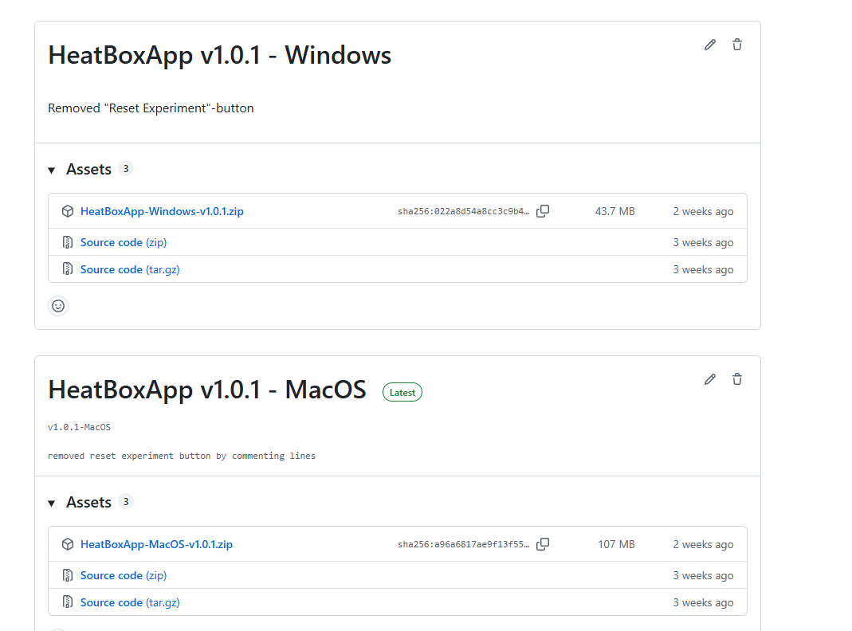



Figure 21

Unzip the folder and locate the application called “HeatBoxApp-(Windows/Mac)-v1.0.x” which is in the same folder as “_internal”, see figure 22. Click this application to start the program.

Figure 22

## Step 4 – Starting the HeatBox

The program should look similar to figure 23 upon startup.

Figure 23

Start by choosing the Serial Port in which the USB cable from the Arduino is connected. This is difficult to know by the name of the port itself, but choose one of the options and see if it works later when starting the machine. If it’s not working, simply choose another one and try again. “Refresh Ports” refreshes the identified USB ports in the menu in which a cable has been connected after starting up the program. So, if you first start the program and then connect the USB cable, make sure to click the “Refresh Ports” button to see if it shows up in the dropdown menu.

After this, if you wish to save the Temperature-, Power- and Time data gathered throughout the experiment. Choose a file location for it to be saved by clicking on “Choose Save Location” and a new Excel file will be created upon finishing the experiment.

“Add comment to file” button simply adds any comment to the Excel file that will be created upon finishing the experiment with the data.

You can now start the experiment by clicking on “Start Experiment”. You will see the plots starting to update similar to figure 24.

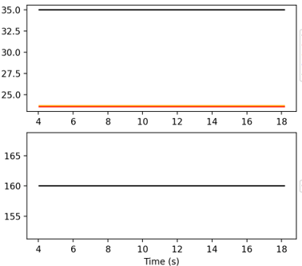

Figure 24

You will see the different temperature sensor readings along with the setpoint temperature on the first plot and the power readings from the heat lamps on the second plot. When you see the graph starting to update, **this is when it’s recommended to plug in the extension cord into the outlet to power up the lamps**.

**Important:** To change the setpoint temperature from the initial value upon startup, simply write the desired temperature the “set point temperature:”-field, click Enter and send click on the “Change set point” button.

When the box has been active for a while the plot will look similar to figure 25. Here you will see how the temperature stabilizes over time and when it gets steady enough for the experiments to be conducted.

Figure 25

When the experiment is over, click on the “Finish Experiment” button. Make sure to unplug the extension cord as well for safety precautions.